cid:image001.jpg@01D2AEC7.9D353300

**Mental Health Support Graduated Response**

**Information for Schools**

Schools play a key role in the early identification of pupils with social, emotional and mental health needs. For children and young people showing signs of SEMH needs, specifically located with the school context, we would expect schools to work within a graduated approach which starts with quality first teaching and informed SEN Support.

Following this approach will help inform initial discussions with pupils and their parents/carers to identify a school-based SEN support plan. This will then help schools to provide health services with evidence of the first line response to a possible SEMH need, which in turn will ensure the most appropriate external agency is accessed at the right time.

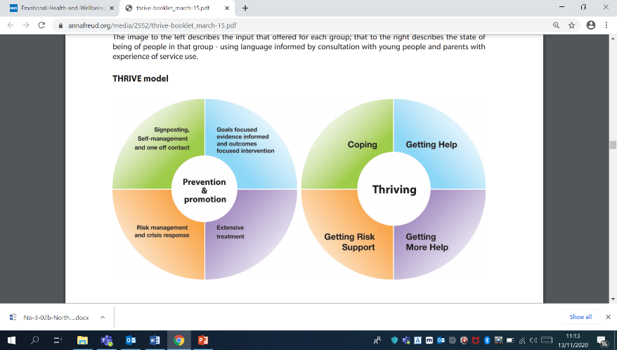

Northumberland has now re-conceptualised its model for provision of emotional and mental health services for children and young people based on the THRIVE model.

**Before accessing targeted mental health services, support needs to have been offered through schools or parents in the first instance. This might include:**

* Emotional Health Nurture Groups

**If behaviours are only seen at home then parenting support would be advised**

* Access to School Counsellor
* Regular and consistent Pastoral Support
* ELSA (or similar to) Targeted Intervention
* Public Health School Nurse Input
* FRIENDS or ROAR Resilience Groups
* Parent drop ins through Sure Start Children’s Centres

**Referrals for 1:1 targeted mental health support will be accepted when:**

* The problem/ issue is not resolving **despite interventions from universal** **services** (school, GP, School Nurse) located in school or the community.
* The problem/ issue is a mental health problem and is having a **significant impact** on the child’s general day-to-day functioning.
* The difficulties are present across **different settings** i.e. at home, at school and in the community.

**Northumberland’s Mental Health Support Graduated Response**

|  |  |  |  |  |
| --- | --- | --- | --- | --- |
| **Stage of Need** | **Context** | **Need** | **Provision** | **Appropriate Services** |
| **Coping** | Focus on promoting resilience; building school and community capacity. | Within this grouping would be children, young people and families adjusting to life circumstances, with mild or temporary difficulties, where the best intervention is within the community with the possible addition of self-support. This group may also include those with chronic, fluctuating or ongoing severe difficulties, for which they are choosing to manage their own health and/or are on the road to recovery. | * Education * Community * Wellness Language used | * School * GP * School Nurses * School Nurse Chat Health Service * Health Visitors * Children’s Centres * Kooth Online * Young Minds |
| **Getting Help** | Focus on good access and early intervention. | This grouping comprises those children, young people and families who would benefit from focused, evidence-based treatment, with clear timescales, aims, and criteria for assessing whether aims have been achieved. This grouping would include children and young people with difficulties that fell within the remit of National Institute for Health and Care 5.2 Coping 5.3 Getting Help 44 Excellence (NICE) guidance and where there are interventions that might help. | * Health as the Lead Provider * Health Language used * Trained Experts * Evidence-Based Treatments * Agreed SMART Outcomes * Care Plan post Treatment | * EMHP * PMHW * Early Help * Talking Matters * Cygnus * Children’s Centres * Health Psychology |
| **Getting More Help** | Focus on conditions requiring extensive treatment. | This grouping comprises those young people and families who would benefit from extensive long-term treatment which may include inpatient care, but may also include extensive community provision. | * Health as the Lead Provider * Health Language used * Specialised Health Workers * Multi-Disciplinary Evidence-Based Treatments * Agreed SMART Outcomes * Care Plan post Treatment | * CYPS * Health Psychology |
| **Getting Risk Support** | Focus on interagency collaboration for particularly vulnerable groups of children and young people and families who remain at risk to themselves or others. | This grouping comprises those children, young people and families 5.4 Getting more help 5.5 Getting risk support 45 who are currently unable to benefit from evidence-based treatment but remain a significant concern and risk. This group might include children, young people who routinely go into crisis but are not able to make use of help offered, or where help offered has not been able to make a difference, who self-harm or who have emerging personality disorders or ongoing issues that have not yet responded to treatment. | * Interagency Collaboration * Lead Provider (most likely Social Care) * Social Care Language used * Health Input via Trained Staff * Health Support offered via Health Staff to support colleagues in helping the child or young person to become therapy ready if a mental health condition is present | * UCT * Emergency Services * Police Street Liaison Team |